26.

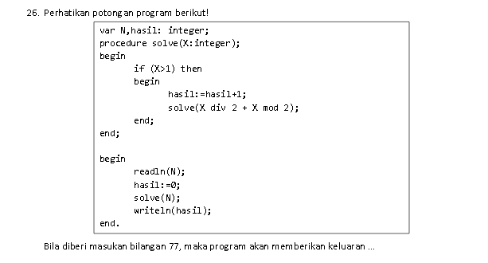

Penyelesaian

Input 77

* input 77 ((77 div 2)+(77 mod 2)) = 38+1 = 39 karna masih lebih dari angka 1 maka di proses lagi
* input 39 ((39 div 2)+(39 mod 2)) = 19+1 = 20 karna masih lebih dari angka 1 maka di proses lagi
* input 20 ((20 div 2)+(20 mod 2)) = 10+0 = 10 karna masih lebih dari angka 1 maka di proses lagi
* input 10 (10 div 2)+(10 mod 2)) = 5+0 = 5 karna masih lebih dari angka 1 maka di proses lagi
* input 5 ((5 div 2)+(5 mod 2)) = 2+1 = 3 karna masih lebih dari angka 1 maka di proses lagi
* input 3 ((3 div 2)+(3 mod 2)) = 1+1 = 2 karna masih lebih dari angka 1 maka di proses lagi
* input 2 ((2 div 2)+(2 mod 2)) = 1+0 = 1 karna tidak lebih dari angka 1 maka proses di hentikan

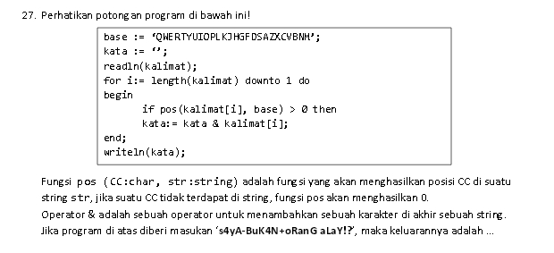

Penyelesaian

input "s4yA-BuK4N+oRanG aLaY!?"

for i := length(kalimat) downto 1 do => "?!YaLa GnaRo+N4KuB-Ay4s"

if pos (kalimat[i], base) > 0 then => true

kata := kata + kalimat[i] => kata := " " + "YLGRNKBA"

kata := YLGRNKBA

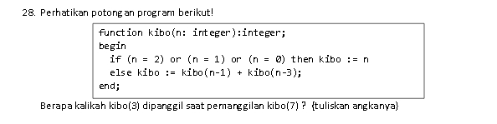

Penyelesaian

Input kibo 7

If (n = 2) or (n=1) or (n=0) then then kibo := 0 => else

(N = 7)

Kibo := kibo(6)+kibo(4)=10

(n=6) (n=4)

((kibo5)+(kibo3))=8 ((kibo3)+(kibo1))=4

(n=5) (n=3) (n=3) (n=1)

((kibo4)+(kibo2))=6 ((kibo2)+(kibo0))=2 ((kibo2)+(kibo0))=2 (kibo1)

(n=4) ( n=2) (n=2) (n=0) ( n=2) (n=0) ( n=1)

(((kibo3)+(kibo 1))=4 (kibo 2) (kibo 2) (kibo 0) (kibo 2) (kibo 0) (kibo1)

(n=3) (n=1) ( n=2) ( n=2) (n=0) ( n=2) (n=0) ( n=1)

((kibo 2)+(kibo 0))=2 (kibo 1) (kibo 2) (kibo 2) (kibo 0) (kibo 2) (kibo 0) (kibo1)

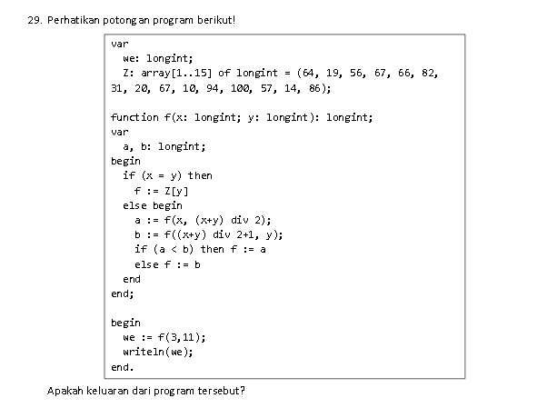

Penyelesaian

29.

(f = 3,11)

a := f(3,(3+11) / 2) => (f=3,7)

b := f((3+11) / 2+1,y) => (f=8,11)

a<b => (f=3,7)

(f = 3,7)

a := f(3,(3+7) / 2) => (f=3,5)

b := f((3+7) /2+1,7) => (f=6,7)

a<b => (f=3,5)

(f=3,5)

a := f(3,(3+5) / 2) => (f=3,4)

b := f((3+5) / 2+1,5) => (f=5,5)

a<b => f(3,4)

(f=3,4)

a := f(3,(3+4) / 2) => (f=3,3) => 56

b := f((3+4) /2+1,4) => (f=4,4) => 67

a<b => f := a => 56<67 => f(3,3)

f(3,3) => z[3] => 56

**kembali ke atas**

a := f(3,4) => 56

b := f(5,5) => z[5] => 66

55<56 => f := a

f(3,5) => 56

-------------------------------

a := f(3,5) := 56

b := f(6,7) := f(7,7) := z[7] => 31

56<31 => f:= b

f(3,7) := 31

------------------------------

a := f(3,7) => 31

b := f(8,11) => f(10,11)

b := f(10,10) => z[10] => 10

31<10 => f := b

f(3,11) => 10

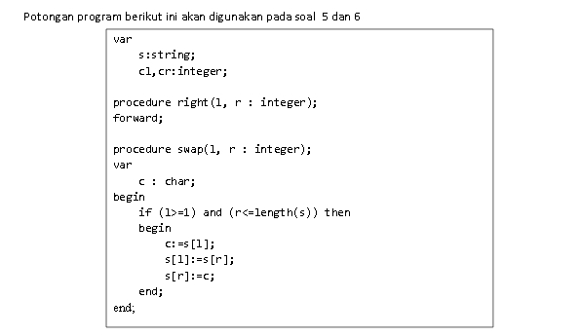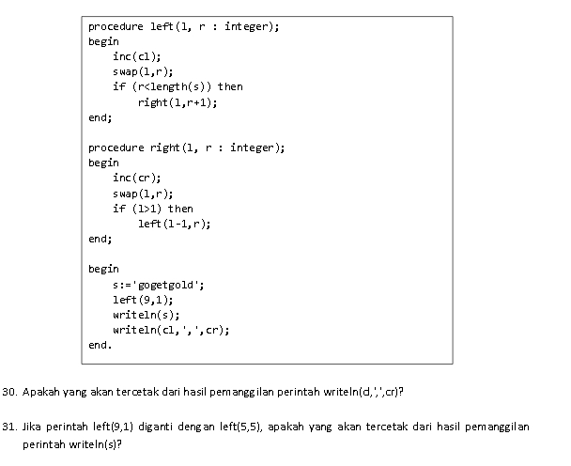

left (9,1)

inc(cl) => cl := 0+1 = 1

cr := 0

swap(9,1)

if (l>=1) and (r<=length(s)) => if (9>=1) and (1<=9) => true

c := s[l] => c := s[9]

s[l] := s[r] => s[9] := s[1] = 'gogetgold' => 'dogetgolg'

s[r] := c => s[1] := c

if (r<length(s)) => if (1<9) then

right(l,r+1) => right(9,2)

right(9,2)

=> cl := 1

inc(cr) => cr := 0+1 = 1

swap(9,2)

if (9>=1) and (2<=9) => true

c := s[9]

s[9] := s[2] = 'dogetgolg' => 'dggetgolo'

s[2] := c

if (l>1) => if (9>1) => true

left(l-1,r) => left(8,2)

left(8,2)

inc(cl) => cl := 1+1 = 2

cr := 1

swap(8,2)

if (8>=1) and (2<=9) => true

c := s[8]

s[8] := s[2] = 'dggetgolo' => 'dlgetgogo'

s[2] := c

if (2<9) then

right(8,3)

right(8,3)

=> cl := 2

inc(cr) => cr := 1+1 = 2

swap(8,3)

if (8>=1) and (3<=9) => true

c := s[8]

s[8] := s[3] = 'dlgetgogo' => 'dlgetgogo'

s[3] := c

if (l>1) => if (8>1) => true

left(l-1,r) => left(7,3)

left(7,3)

inc(cl) => cl := 2+1 = 3

cr := 2

swap(7,3)

if (7>=1) and (3<=9) => true

c := s[7]

s[7] := s[3] = 'dlgetgogo' => 'dloetgggo'

s[3] := c

if (3<9) then

right(7,4)

right(7,4)

=> cl := 3

inc(cr) => cr := 2+1 = 3

swap(7,4)

if (7>=1) and (4<=9) => true

c := s[7]

s[7] := s[4] = 'dloetgggo' => 'dlogtgego'

s[4] := c

if (l>1) => if (7>1) => true

left(l-1,r) => left(6,4)

left(6,4) => inc(cl) := 3+1 = 4

cr := 3

'dlogtgego'

right(6,5) => cl := 4

inc(cr) := 3+1 = 4

'dloggtego'

left(5,5) => inc(cl) := 4+1 = 5

cr := 4

'dloggtego'

right(5,6) => cl := 5

inc(cr) := 4+1 = 5

'dlogtgego'

left(4,6) => inc(cl) := 5+1 = 6

cr := 5

'dlogtgego'

right(4,7) => cl := 6

inc(cr) := 5+1 = 6

'dloetgggo'

left(3,7) => inc(cl) := 6+1 = 7

cr := 6

'dlgetgogo'

right(3,8) => cl := 7

inc(cr) := 6+1 = 7

'dlgetgogo'

left(2,8) => inc(cl) := 7+1 = 8

cr := 7

'dggetgolo'

right(2,9) => cl := 8

inc(cr) := 7+1 = 8

'dogetgolg'

left(1,9) => inc(cl) := 8+1 = 9

cr := 8

'gogetgold'

jadi hasil dari left(9,1) adalah :

(s) : 'gogetgold'

cl : 9 cr : 8

31.

left(5,5)

prosesnya sama seperti no 30, dan hasil dari left(5,5) adalah :

(s) : 'tdlogegog'

(cl) : 5 (cr) : 4

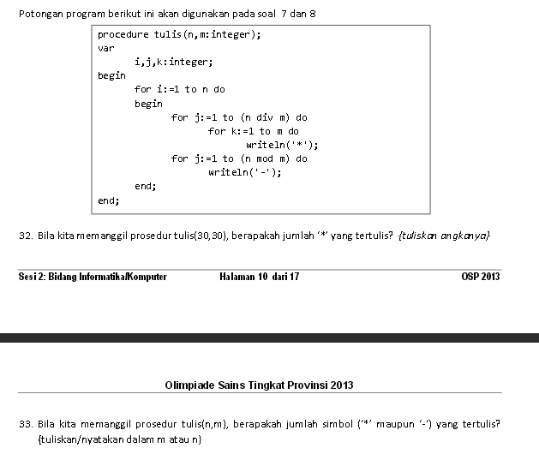

Penyelesaian

32.

n,m => (5,5)

for k := 1 to (5 div 5) do = 1

for k := 1 to 5

* = 5*5 = 25

for j :+ 1 to (5 mod 5) do = 0

- = 5*0 = 0

output

*************************

33.

n,m => (5,2)

for k := 1 to (5 div 2) do = 2

for k := 1 to 2

*= 5*2 = 10

for j := 1 to (5 mod 2) do = 1

- = 5*1 = 5

output

**-**-**-**-**-

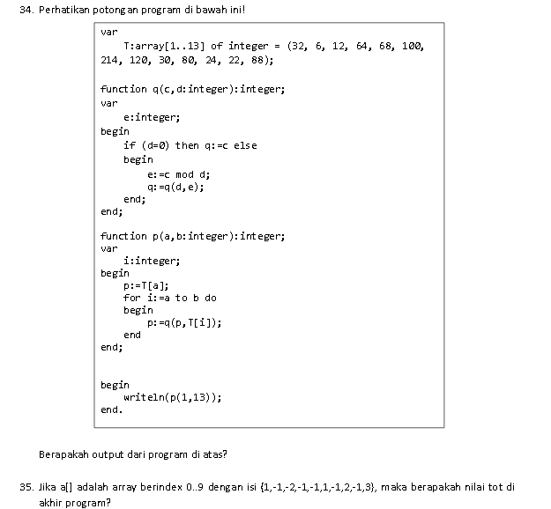

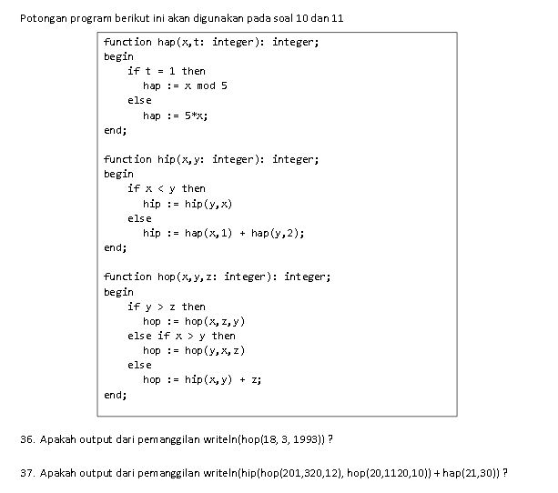

36.

hop(x,y,z) = hop(18,3,1993)

if y>z = 3>1993 => false

if x>y = 18>3 => true

hop := hop(3,18,1993)

if y>z = 18>1993 = false

if x>y = 3>18 => false

hop := hip(3,18) + 1993;

hip(x,y) + z = hip (3,18) + 1993

if x<y = 3<18 => true

hip := hip(18,3)

if 18<3 => false

hip := hap(18,1) + hap (3,2)

hap(x,t) = hap((x,t => 18,1) and (x,t => (3,2)

(x,t) = (18,1)

if t = 1 true

hap := 18 mod 5 => 3

(x,t) = (1993,2)

if t = 1 false

hap := 5*3 => 15

hip := (18,3)

hip = hap(18,1) + hap(3,2) = 18

hap = 3 + 15 = 18

hop := hip (3,18)+1993

18 + 1993 = 2011

37.

(hip(hop(201,320,12),hop(20,1120,10))+hap(21,30))

hop (x,y,z) = hop(201,320,12)

if y>z = 320>12 => true

hop := hop (201,12,320)

if y>z = 12>320 => false

if x>y = 201>12 => true

hop := hop(12,201,320)

if y>z = 201>320 => false

if x>y = 12>201 => false

hop := hip(12,201) + 320

hip (x,y) + z = hip(12,201)+320

if x<y = 12<201 => true

hip := hip(201,12)

if x<y = 201<12 => false

hip := hap(201,1) + hap(12,2);

hap (x,1)+hap(x,2) = hap(201,1)+hap(12,2)

if t = 1 => true

hap := 201 mod 5 => 1

if t = 1 => false

hap := 5*12 = 60

hip := hap(201,1)+hap (12,2)

1 + 60 = 61

hip := hip(12,201) + 320

61 + 320 = 381

hop (x,y,z) = hop(20,1120,10)

if y>z = 1120>10 => true

hop := hop (20,10,1120)

if y>z = 10>1120 => false

if x>y = 20>10 => true

hop := hop(10,20,1120)

if y>z = 20>1120 => false

if x>y = 10>20 => false

hop := hip(10,20) + 1120

hip (x,y) + z = hip(10,20)+1120

if x<y = 10<20 => true

hip := hip(10,20)

if x<y = 20<10 => false

hip := hap(20,1) + hap(10,2);

hap (x,1)+hap(x,2) = hap(20,1)+hap(10,2)

if t = 1 => true

hap := 20 mod 5 => 0

if t = 1 => false

hap := 5*10 = 50

hip := hap(20,1)+hap (10,2)

0 + 50 = 50

hip := hip(10,20) + 1120

50 + 1120 = 1170

hip(x,y) = hip(381,1171)

if x>y = 381<1170 => true

hip := hip(1170,381)

if x>y = 1170<381 => false

hip := hap(1170,1)+hap(381,2)

hap(x,1)+hap(x,2) = hap(1170,1)+hap(381,2)

if t = 1 = true

hap := 1170 mod 5 => 0

if t = 1 = false

hap := 5*381 => 1905

hip(381,1170)

hip := hap(1170)+hap(381,2)

0 + 1905 => 1905

hap(21,30)

if t = 1 =false

hap := 5*21 n=> 105

(hip(hop(201,320,12),hop(20,1120,10))+hap(21,30))

1905 + 105 = 2010

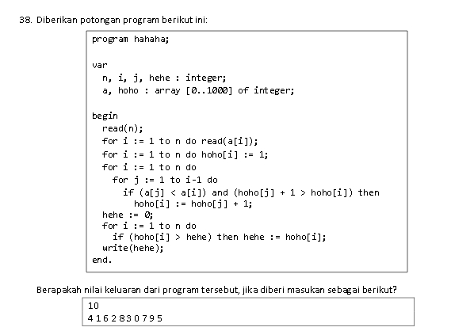

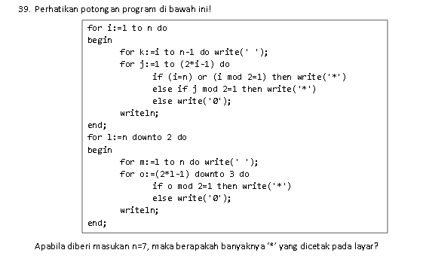

Penyelesaian

39.

n = 10

((i=n) or

(i mod 2=1) or => ('*') (j mod 2=1)) => ('*')

i else => ('0') j

1 * (2*1-1)= 1 *

2 0 (2*2-1)= 3 *

3 * (2*3-1)= 5 *

4 0 (2*4-1)= 7 *

5 * (2*5-1)= 9 *

6 0 (2*6-1)= 11 *

7 * (2*7-1)= 13 *

8 0 (2*8-1)= 15 *

9 * (2*9-1)= 17 *

10 * (2*10-1)= 19 *

for i := 1 to n do

for k := i to n-1 do write (' ')

for j := 1 to (2*i-1) do

if (i=n) or (i mod 2=1) then write ('*')

else if j mod 2=1 then write('*')

else write('0');

l (2*l-1) = o (o mod 2 = 1) => ('*')

else => ('0')

10 (2*10-1)= 19 *

9 (2*9-1)= 17 *

8 (2*8-1)= 15 *

7 (2*7-1) = 13 *

6 (2*6-1) = 11 *

5 (2*5-1) = 9 *

4 (2*4-1) = 7 *

3 (2*3-1) = 5 *

2 (2*2-1) = 3 *

for l := n down to 2

for m := l to n do write (' ')

for o := (2*l-1) downto 3 do

if o mod 2 = 1 then write ('*')

else write ('0')

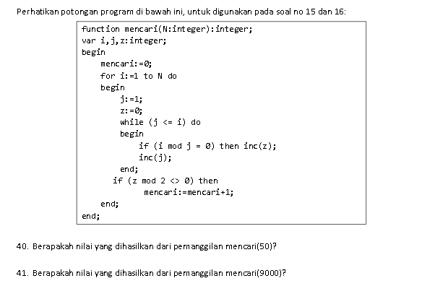

Penyelesaian

40 dan 41

hasil simple nya, n dapat di bagi berapa saja, dan ada berapa angka, nah jumlah dari banyak nya yang dapat di bagi n tersebut bila hasilnya ganjil maka hasilnya sama persis, dan jika hasilnya genap maka hasil tersebut di kurang 1.

mencari := 0

j := 1

z := 0

for i := 1 to n

1. while (j <= i) => while (1 <= 1)

if ( i mod j = 0) => (1 mod 1 = 0) true

=> inc(z) = z := 1

=> inc(j) = j := 2

if ( i mod j = 0) => (1 mod 2 = 0) false

=> if (z mod 2 <> 0) => (1 mod 2 <> 0) true => mencari + 1 = mencari := 1

2. while (2 <= 2)

if ( i mod j = 0) => (2 mod 1 = 0) true

=> inc(z) = z := 1

=> inc(j) = j := 2

if ( i mod j = 0) => (2 mod 2 = 0) true

=> inc(z) = z := 2

=> inc(j) = j := 3

=> if (z mod 2 <> 0) => (2 mod 2 <> 0) false => mencari := 1

3. while (4 <= 4)

if ( i mod j = 0) => (4 mod 1 = 0) true

=> inc(z) = z := 1

=> inc(j) = j := 2

if ( i mod j = 0) => (4 mod 2 = 0) true

=> inc(z) = z := 2

=> inc(j) = j := 3

if ( i mod j = 0) => (4 mod 3 = 0) false

=> inc(z) = z := 2

=> inc(j) = j := 4

if ( i mod j = 0) => (4 mod 4 = 0) true

=> inc(z) = z := 3

=> inc(j) = j := 5

=> if (z mod 2 <> 0) => (3 mod 2 <> 0) true => mencari := 2

jadi, program ini menentukan jumlah mencari bila (z mod 2 <> 0) maka mencari + 1

jadi,

=> total mencari bila (n = 50) adalah = 7

=> total mencari bila (n = 9000) adalah = 94

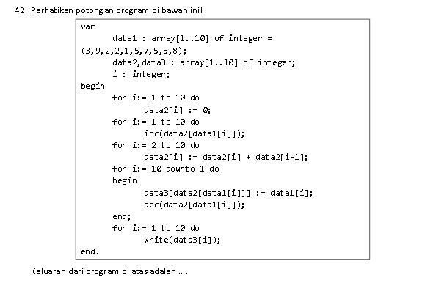

Penyelesaian]

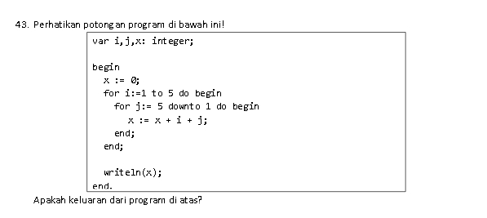

Penyelesaian

43,

x + i + j => x

0 + 1 + 1 => 2

2 + 1 + 2 => 5

5 + 1 + 3 => 9

9 + 1 + 4 => 14

14 + 1 + 5 => 20

20 + 2 + 1 => 23

23 + 2 + 2 => 27

27 + 2 + 3 => 32

32 + 2 + 4 => 38

38 + 2 + 5 => 45

45 + 3 + 1 => 49

49 + 3 + 2 => 54

54 + 3 + 3 => 60

60 + 3 + 4 => 67

67 + 3 + 5 => 75

75 + 4 + 1 => 80

80 + 4 + 2 => 86

86 + 4 + 3 => 93

93 + 4 + 4 => 101

101 + 4 + 5 => 110

110 + 5 + 1 => 116

116 + 5 + 2 => 123

123 + 5 + 3 => 131

131 + 5 + 4 => 140

140 + 5 + 5 => 150

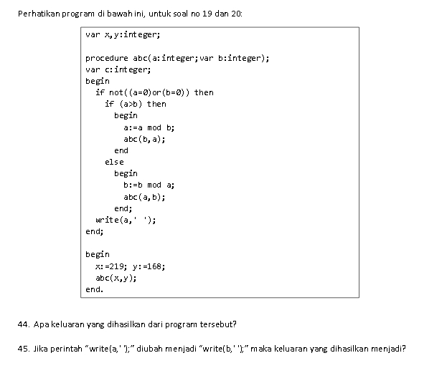

Penyelesaian

44 dan 45.

a := 219 b := 168

a>b then a b abc

219>168= true 219 mod 168 = 51 168 168,51

168>51 = true 168 mod 51 = 15 51 51,15

51>15 = true 51 mod 15 = 6 15 15,6

15>6 = true 15 mod 6 = 3 6 6,3

6>3 = true 6 mod 3 = 0 3 3,0

3>0 = true b = 0 = 3 0

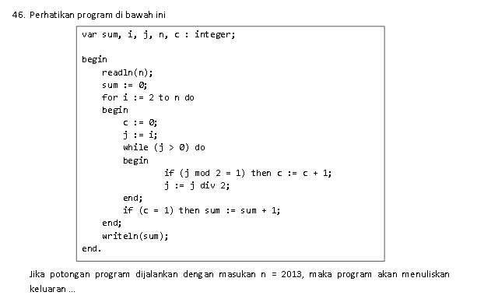

Penyelesaian

46.

secara simple (j*n-1) => (1*2013)-1 = 2012

n = 2013

for i := 2 to n do

j := 1

i := 2013 - 1 => 2012

while (1>0) do

if (1 mod 2 = 1) true => c+1;

if (c = 1) => sum+1

(sum+1) di proses sebanyak 2012 kali, jadi hasil dari sum adalah 2012

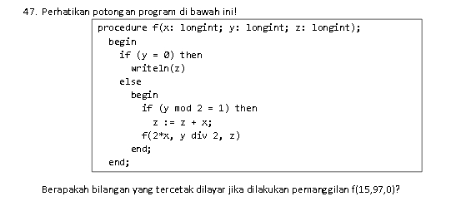

Penyelesaian

47. f(x,y,z) => f (15,97,0)

=> if (y = 0) => false

if (y mod 2 = 1) => (97 mod 2 = 1) = true

z := 0 + 15 = 15

f(2*15,97 div 2,z) => f(30,48,15)

=> if (y = 0) => false

if (y mod 2 = 1) => (48 mod 2 = 1) = false

f(2*x,y div 2,z) => f(2*30,48 div 2,15) = f(60,24,15)

=> if (y = 0) => false

if (y mod 2 = 1) => (24 mod 2 = 1) = false

f(2*x,y div 2,z) => f(2*60,24 div 2,15) = f(120,12,15)

=> if (y = 0) => false

if (y mod 2 = 1) => (12 mod 2 = 1) = false

f(2*x,y div 2,z) => f(2*120,12 div 2,15) = f(240,6,15)

=> if (y = 0) => false

if (y mod 2 = 1) => (6 mod 2 = 1) = false

f(2*x,y div 2,z) => f(2*240,6 div 2,15) = f(480,3,15)

=> if (y = 0) => false

if (y mod 2 = 1) => (3 mod 2 = 1) = true

z := 15 + 480 = 495

f(2*x,y div 2,z) => f(2*480,3 div 2,495) = f(960,1,495)

=> if (y = 0) => false

if (y mod 2 = 1) => (1 mod 2 = 1) = true

z := 495 + 960 = 1455

f(2*x,y div 2,z) => f(2*960,1 div 2,1455) = f(1920,0,1455)

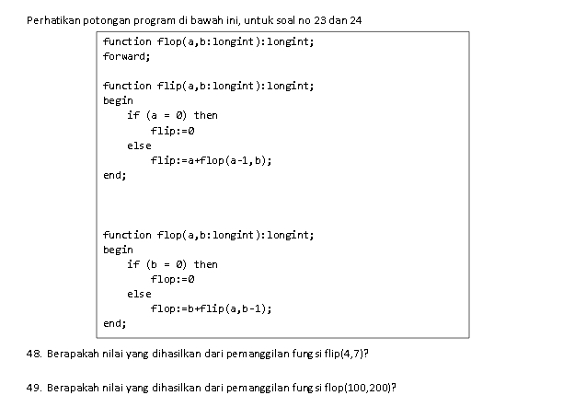

Penyelesaian

48. flip (4,7)

if (a=0) => flip := 0

if (b=0) => flop := 0

flip := a+flop(a-1,b) => flip := 4+flop(3,7)

flop := b + flip(a,b-1) => flop := 7 + flip(3,6)

flip := a + flop(a-1,b) => flip := 3 + flop(2,6)

flop := b + flip(a,b-1) => flop := 6 + flip(2,5)

flip := a + flop(a-1,b) => flip := 2 + flop(1,5)

flop := b + flip(a,b-1) => flop := 5 + flip(1,4)

flip := a + flop(a-1,b) => flip := 1 + flop(0,4)

flop := b + flip(a,b-1) => flop := 4 + flip(0,3)

flip(0,3) => 0

4 + 7 + 3 + 6 + 2 + 5 + 1 + 4 + 0 = 32

49. flop(100,200)

Prosesnya sama seperti no 48 dengan hasil nilai = 20200

